The specification and design

Group 3

Qujie Chen, Shukai Fang, Beibei Zhang

**Nonfunctional Requirements**

**1. Operational Requirements**

1.1. The system will operate in Windows environment.

1.2. The system will fit in iPhone X environment.

**2. Performance Requirements**

2.1. The system will show the Google Map after the user login the system

**3. Security Requirements**

3.1. Only admin can set their availability.

3.2. Only admin can change the content of the events.

**4. Cultural and Political Requirements**

4.1. No special cultural and political requirements are anticipated.

**Functional Requirements**

1. Login Requirements

1.1 User first name/last name <=50 char, passport/user name < 20 char

**2. Check the new event on the map**

2.1. User see the event information

2.2. User can give a like to the interested event

3. Page Requirements

3.1 Memo page shows all the events that the user participated

3.2 Club page shows the recommendation events from current organization

4. Receive Email

4.1 User can receive confirmation email after he/she buy the ticket.

5. Map

5.1 All the similar event will be collected in the same category

5.2 The event will show up when the user clicks on the bubble on the map

5.3 The map limited to the region of Syracuse that user cannot move the cursor the region out of Syracuse

Use Case Diagram

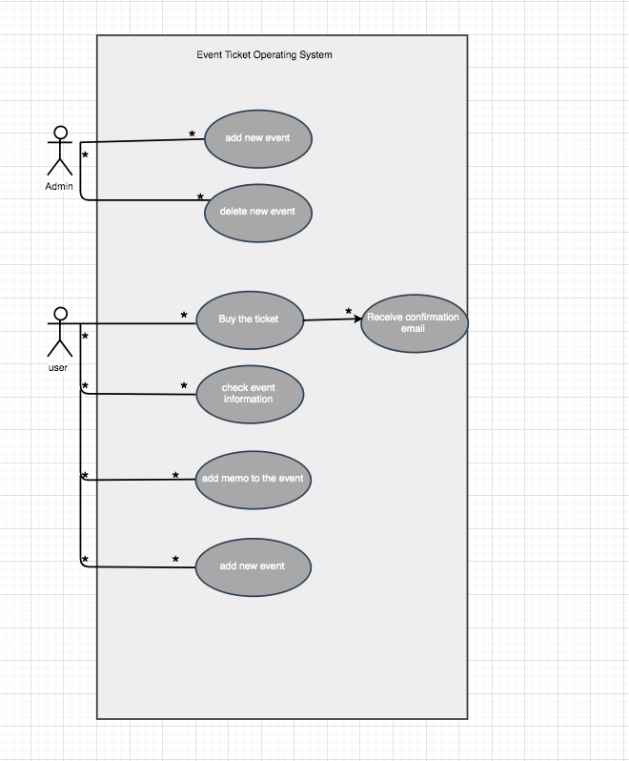

Sequence Buy ticket use case

